So the question is, how much has the last two years of growth reduced the output gap opened by the recession, and what are the prospects for the Fed meeting its mandates of full employment and price stability any time soon.
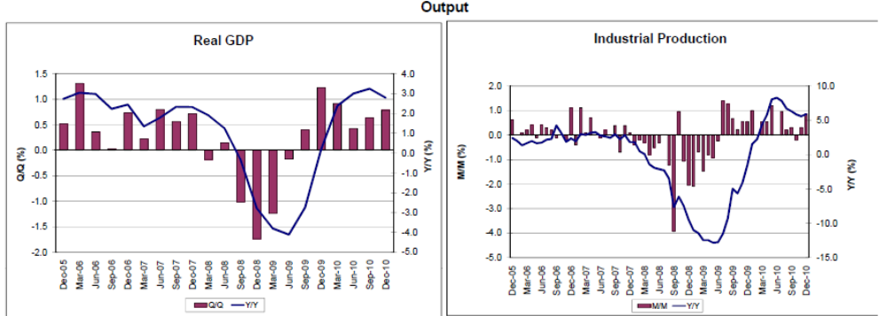
Not much sign here of much more than the leveling off at the modest levels of growth we’ve seen for the last year or so, though final demand and apparent inventory depletion in q4 bodes well for a modestly better q1 .
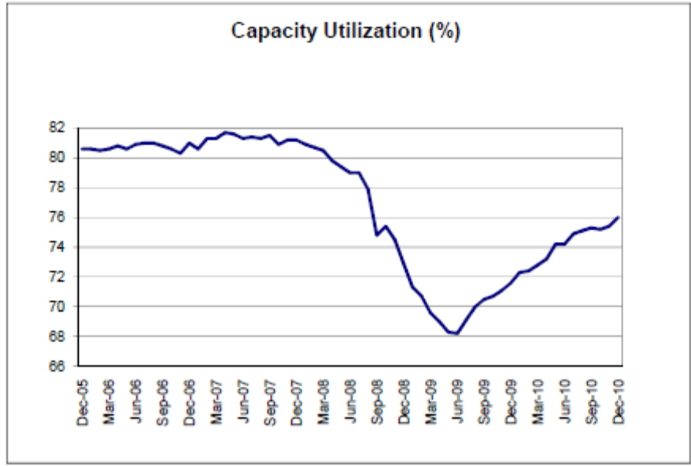
After nearly 2 years it looks like it could be another 18 months before this indicator gets to pre recession levels which weren’t all that high to begin with.

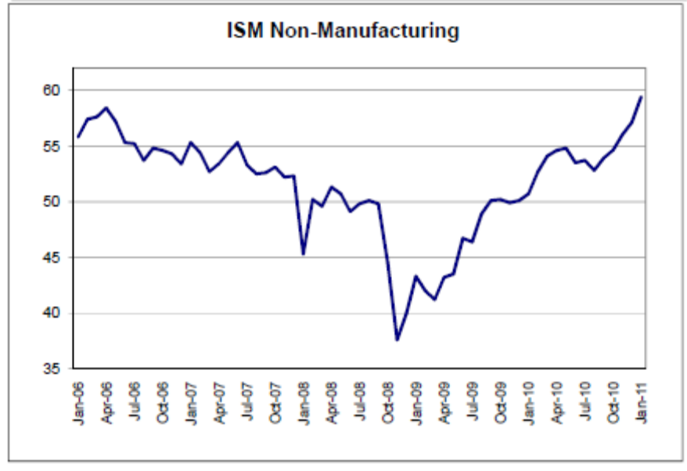
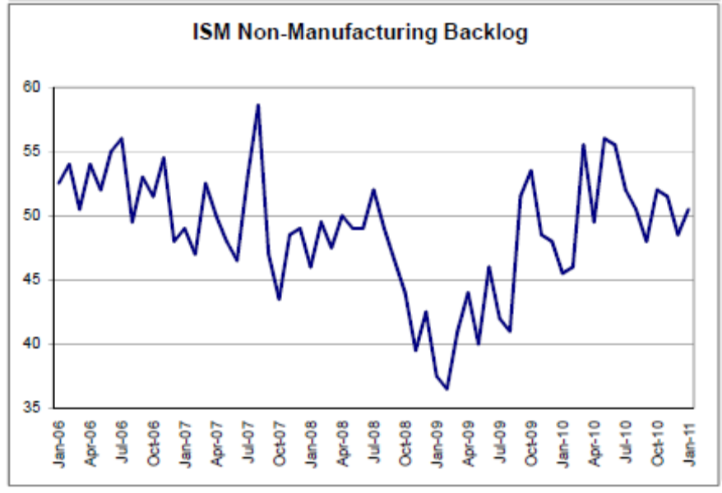

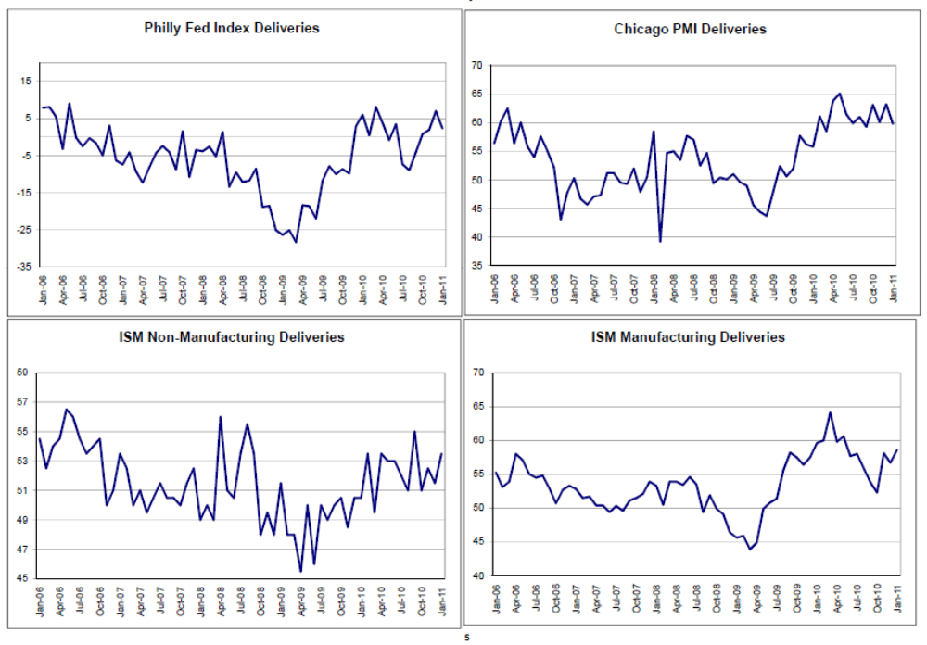
A pick up in the number of business looking at overall improvement, but seems it took that kind of improved outlook to keep backlogs and deliveries at levels suggesting continued modest growth.

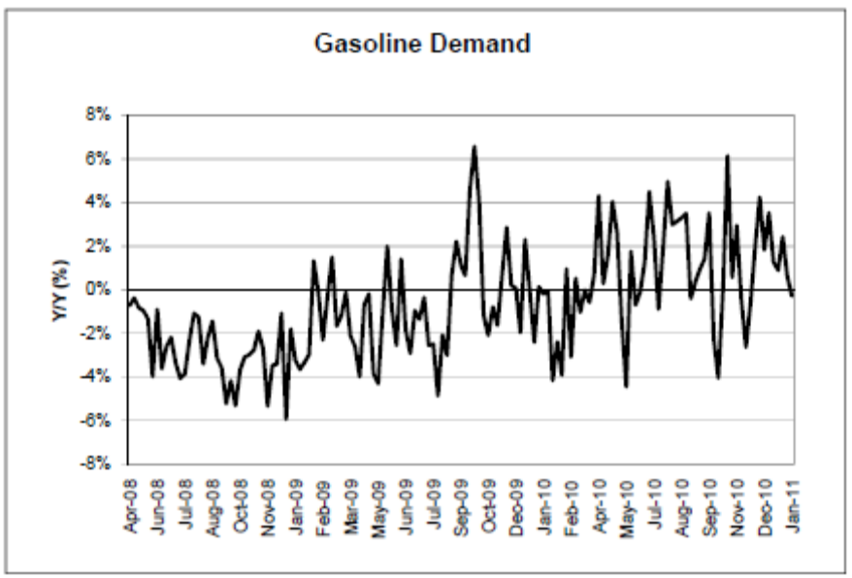
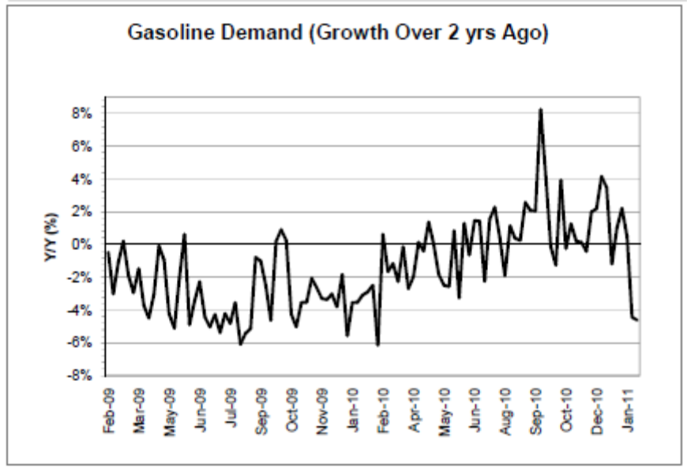

Gasoline demand year over year and vs 2 years ago so far isn’t showing much in the way of growth.

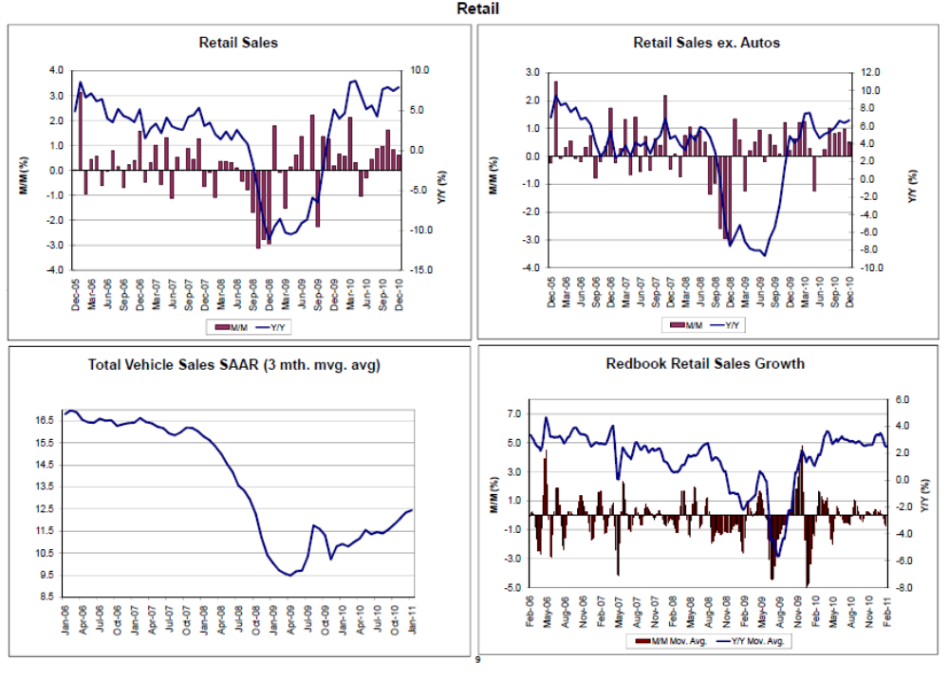
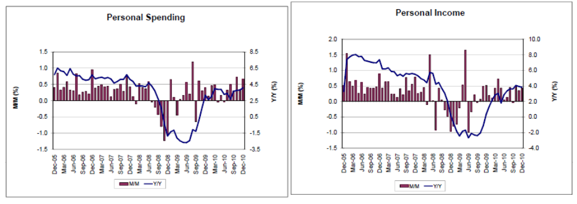
Retail sales seem to have leveled off as well, with autos returning to pre recession levels at a very slow pace. And none of this is likely to accelerate without a bit more help from personal income which seems to have leveled off well below pre recession levels which weren’t associated with particularly high rates of gdp growth.
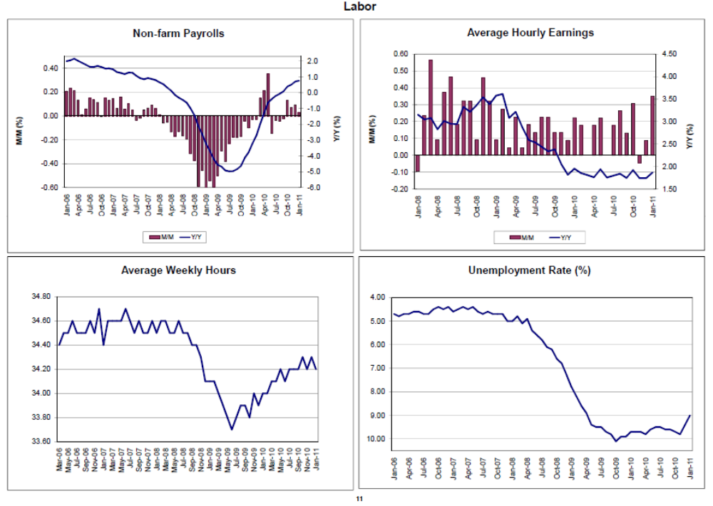
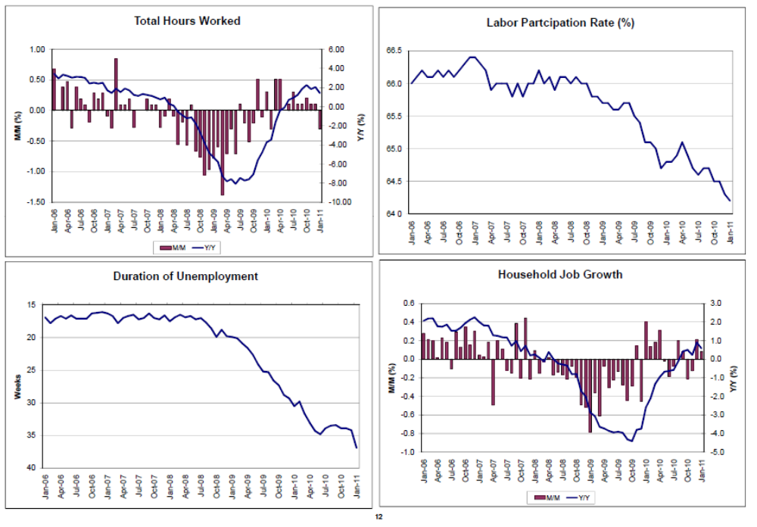
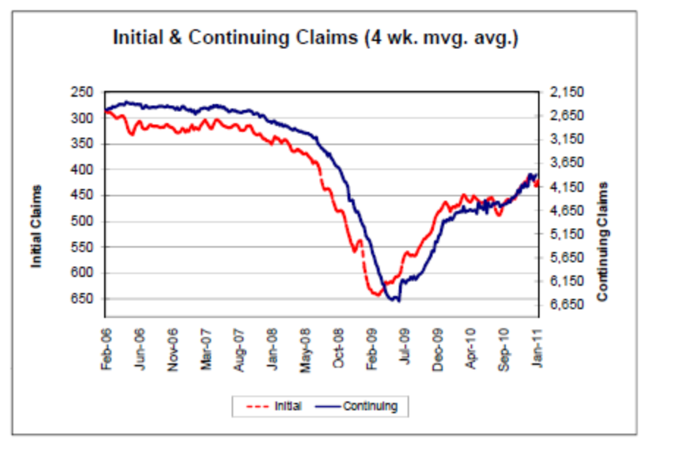
For all the fuss around the last employment report, it all looks to me more a leveling off than like acceleration, though we need to see another month to see if the December weather has masked anything.

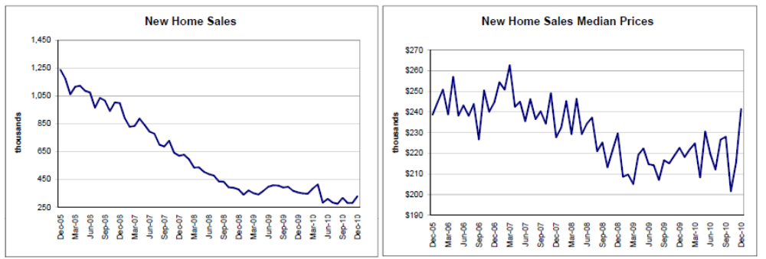
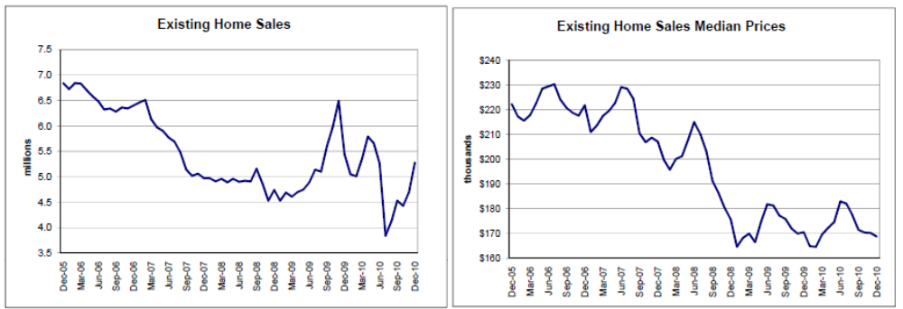
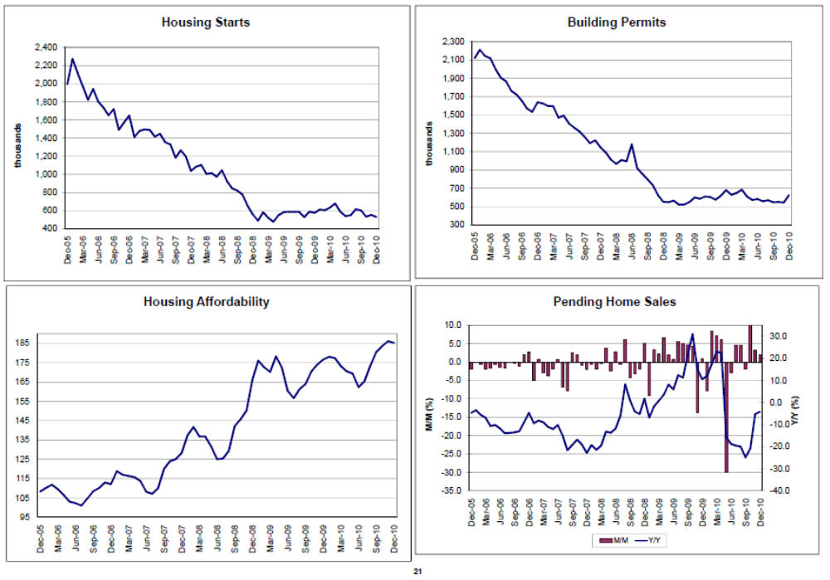
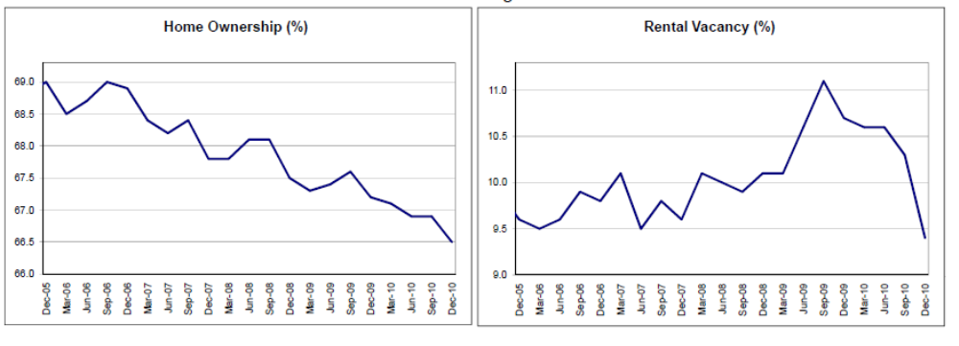
Even with affordability up and rental vacancy down, indicating tightening supply, housing still looks like it’s dragging on the bottom. The higher new home price may be a sign of crossing the macro bid/offered spread as old supplies dwindle and new buyers of new homes have to pay cost plus profit to builders even with weak demand, or the house won’t get built.
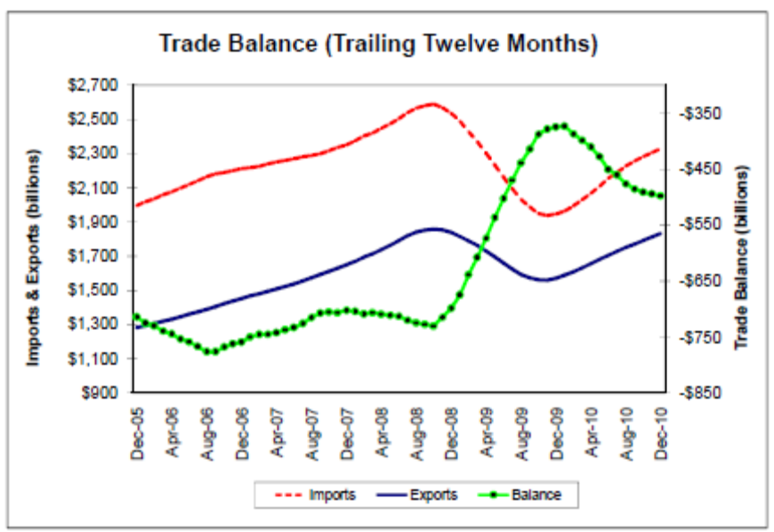
Imports growing a bit faster than exports, partially due to rising crude prices, and neither displaying a rate of growth much different from pre recession levels.
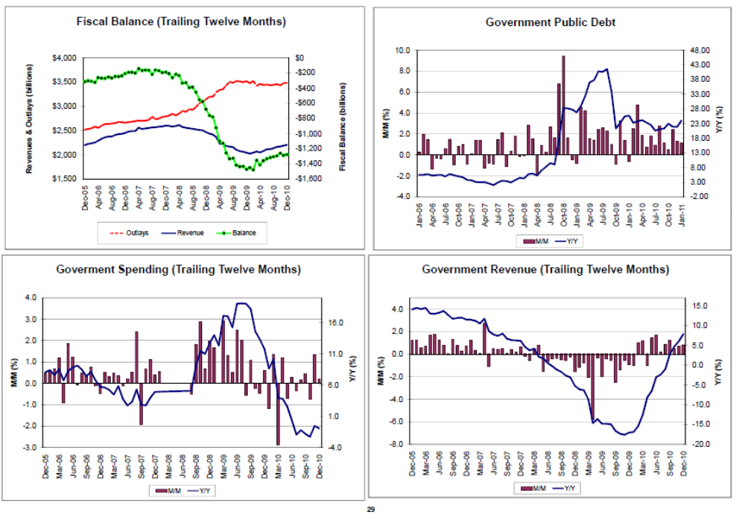
The deficit is coming down more in an L shaped manor than the V shape I’d expect with anything more than modest growth.
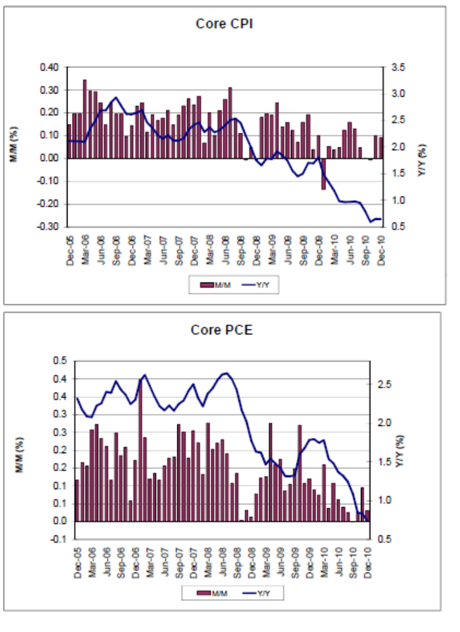
This gets the Fed’s attention. They are a lot more concerned about fighting the devil they don’t know- deflation, than the devil they think they know- inflation.
So given that the risks are asymmetrical they are likely to stay on hold until they reverse.
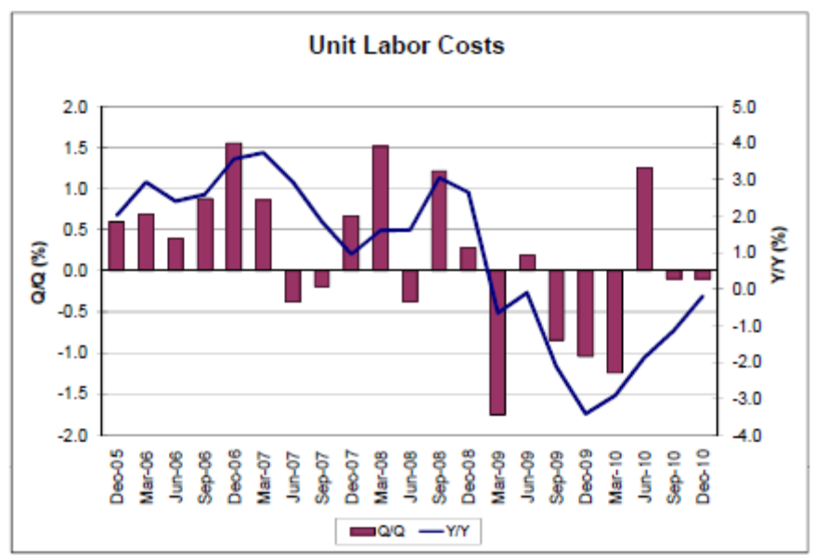
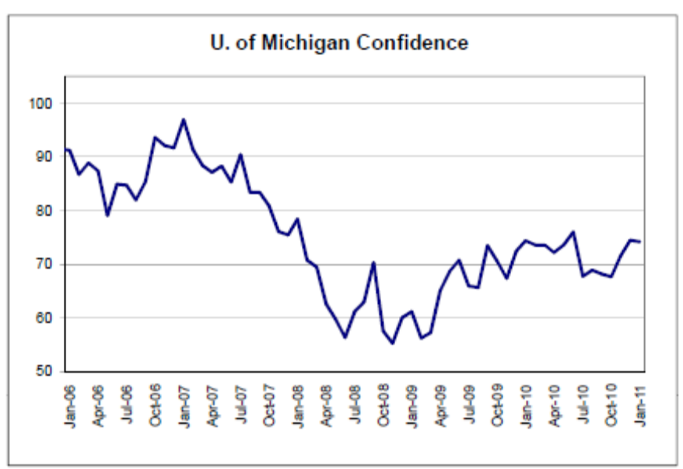
Mainstream theory says elevated inflation expectations are the cause of inflation, and prime transmission channels are rising wages and accelerated purchases, so no sign here of being anywhere near inflation.

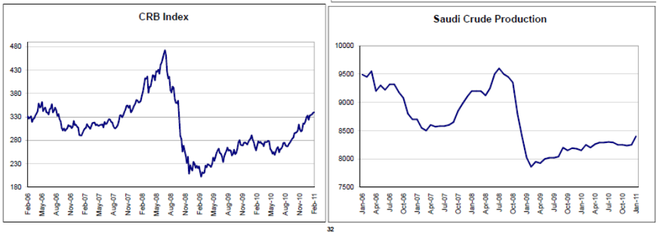
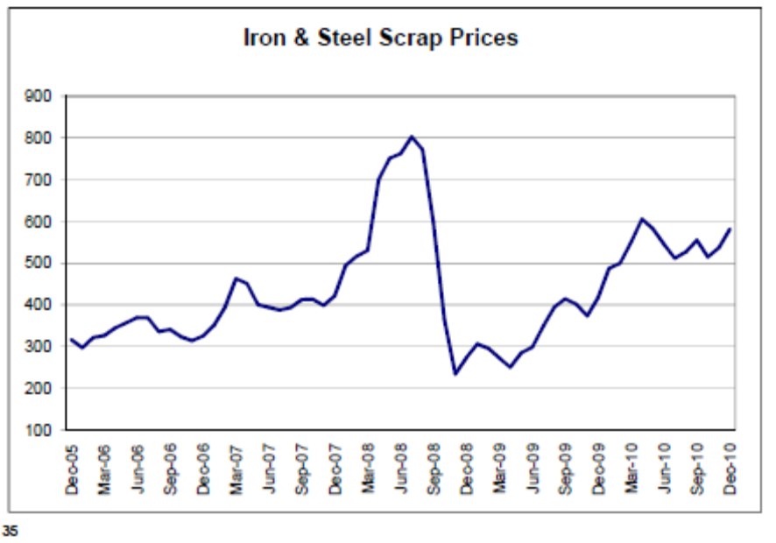
All looking relatively tame here as well.
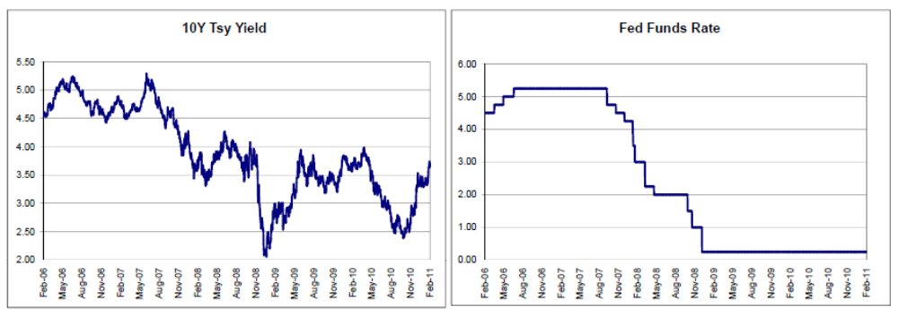
If we are going the way of Japan, 10 year yields will continue to work their way irregularly lower.

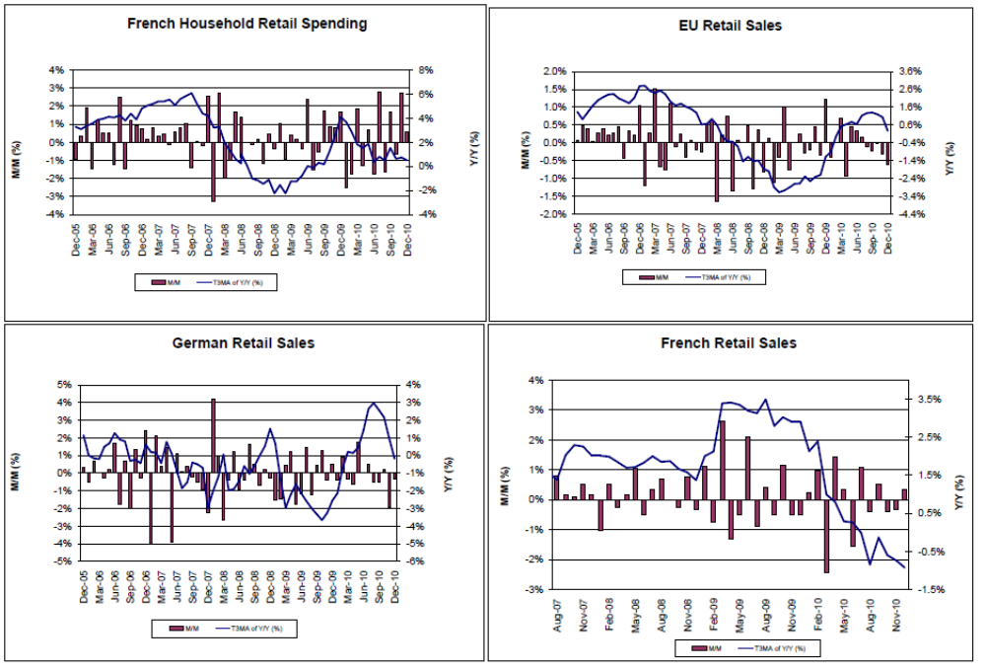
Europe has been a disaster for the consumer for a long time, with no sign of fundamental change, as we await the settling in of the already in place austerity measures which should make it all a lot worse.
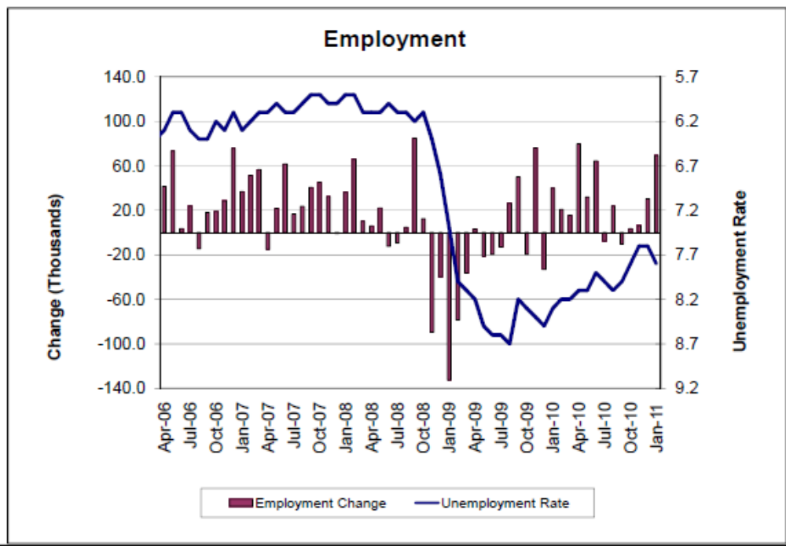

Canada’s financial sector may have escaped the financial crisis, but the real economy took a hit, which is functionally all that matters.
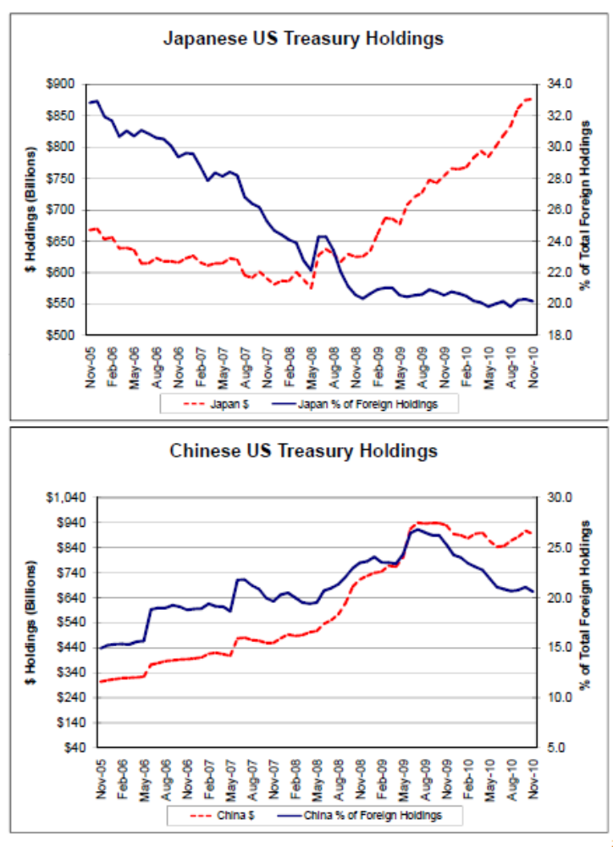
Japan’s holding going up says they are buying dollars?
And China’s flattening says they are not?

